EasyChair system instructions for Authors

The submission and review of papers for BME10 (2024) will be managed through an online conference paper management system called EasyChair. This system gives you complete control over your submission. You can upload the abstract, full-text paper and check on the review status of your submission. The submission process consists of four main stages:
- Abstract submission
- Full-text paper submission
- Revised paper submission
- Final paper submission
The Program Committee will review all abstracts and notify the authors of the results. The authors of accepted abstracts will be required to submit a Full-text paper. The full-text papers will be checked for plagiarism and revised with the help of anonymous reviewers. Authors of accepted full-text papers will be asked to submit a revised version if there are any requests for corrections from independent reviewers. A final paper will be submitted after the final English test. This guide is intended to assist authors in the submission process. It has five parts:
- Set up an account with EasyChair
- Abstract submission
- Full-text paper submission
- Revised paper submission
- Final paper submission
Although the submission process is not complicated, some authors will encounter problems. We are happy to help you with this. If you have any problem or need help, please get in touch with us at email address: bme.conf@hcmiu.edu.vn.

- Set up an account with EasyChair as an Author (If you don’t have an Easychair account).
First, You must set up an account (username and password) as the author. Go to https://easychair.org/conferences/?conf=bme10 and select "Create an account". You will then be automatically redirected to the page shown in Figure 1. Select " I'm not a robot" and click on "Continue".
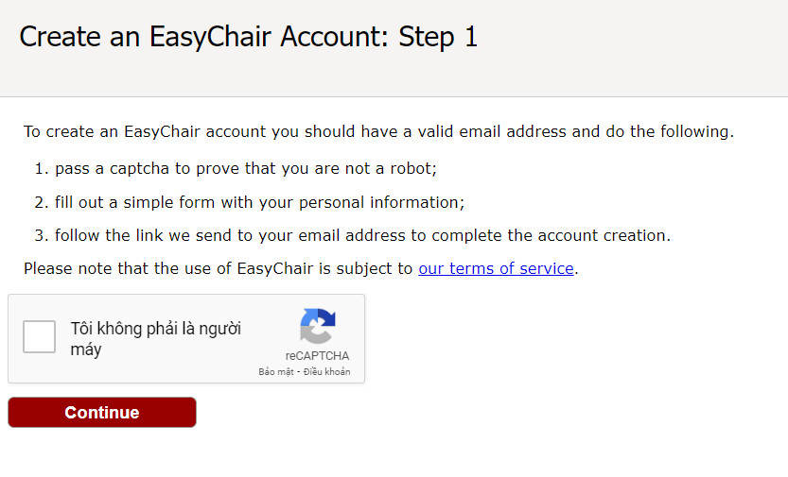
Figure 1. Confirm the information and prove that "I am not a robot."
Then, follow the on-screen instructions, complete the form (as shown in Figure 2), and click on “Continue”.
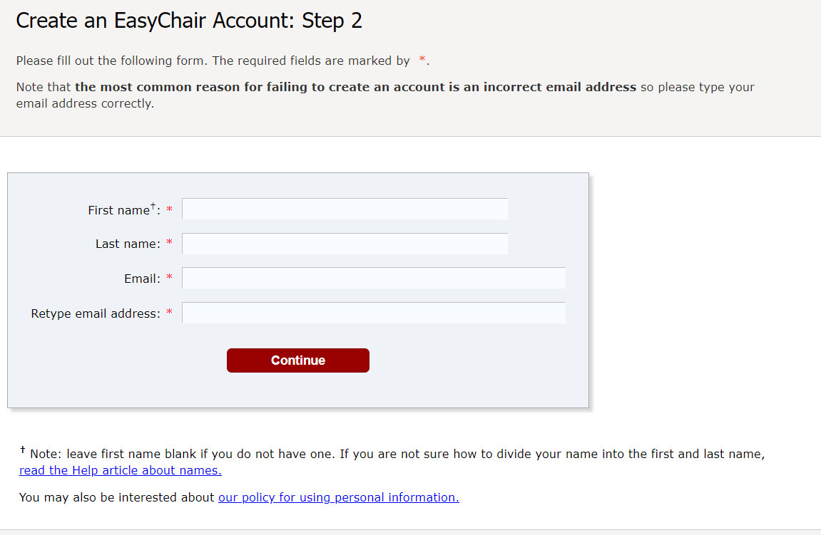
Figure 2. Fill in the form
After registering, you will receive an email similar to the one in Figure 3. Use the link provided in the email to continue the account registration process.
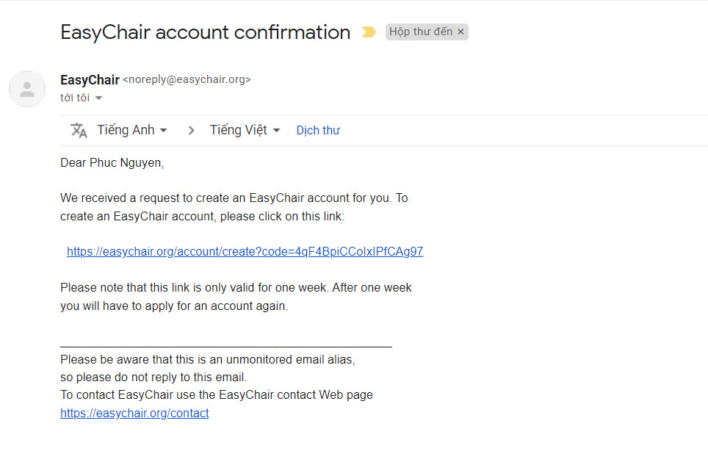
Figure 3. Login Email
Fill out all the required information (as shown in Figure 4), and click the “Create my account” button to finalize the account registration process.
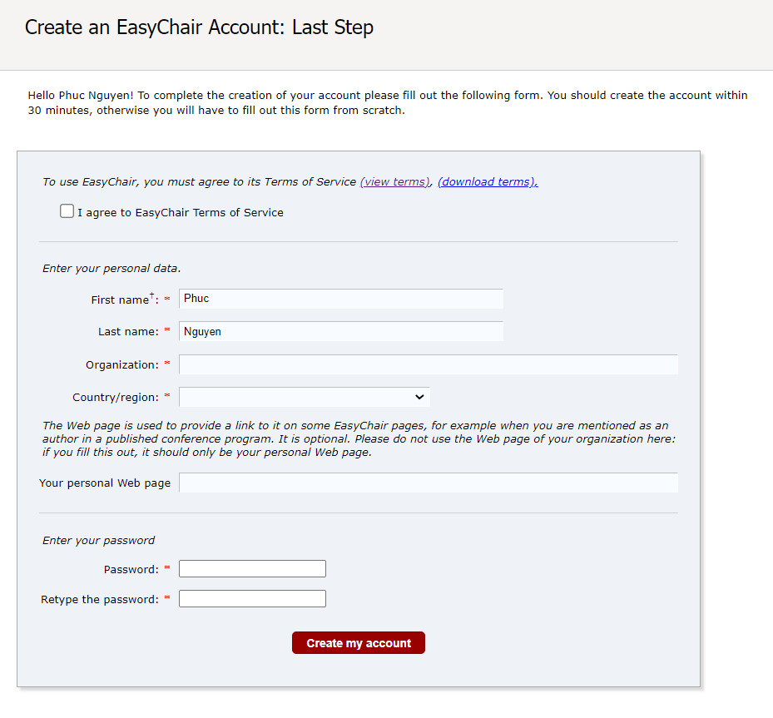
Figure 4. Create an account
A successfully created account will be notified, as shown in Figure 5
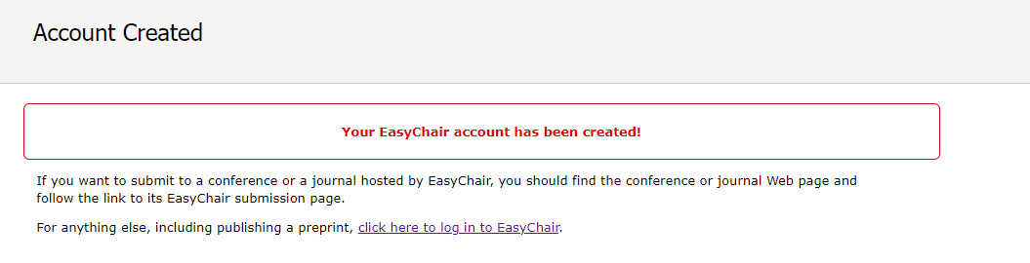
Figure 5. The account has been created.
After registering the account, you may log in to BME10 simply by clicking on the “click this link” link (as shown in Figure 5), then click on the following link: https://easychair.org/conferences/?conf=bme10.
Note: If your username appears taken, you may have signed up for EasyChair in the past for another conference. In this case, you simply need to ask the system to remind you of your password based on your username and access the conference through the link to the BME10 conference as above.
- Abstract submission
After logging in to the BME10’s EasyChair system, you may click on “ make a new submission” to submit your abstract (Figure 6).
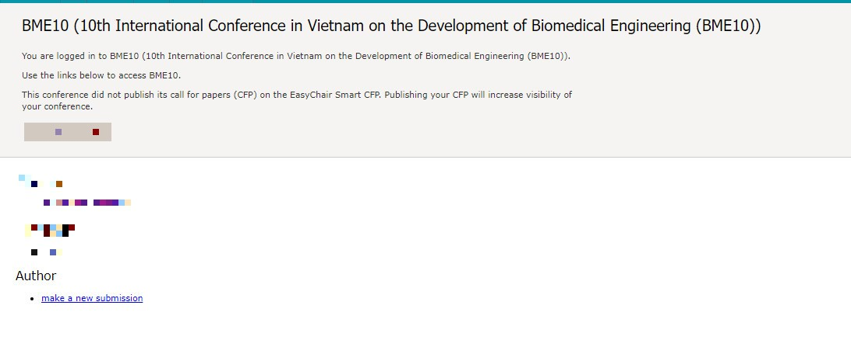
Figure 6. The main page for the author
Follow the on-screen instructions and fill out all required information (as shown in Figure 7) about the authors.
Note: You must use the email address you signed up with when creating the EasyChair account.
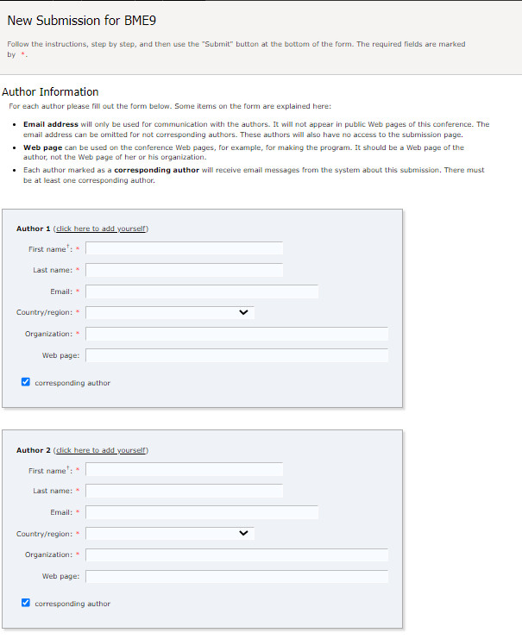
Figure 7. Authors information
Fill out the text abstract, keywords, and add the abstract file (as shown in Figure 8).
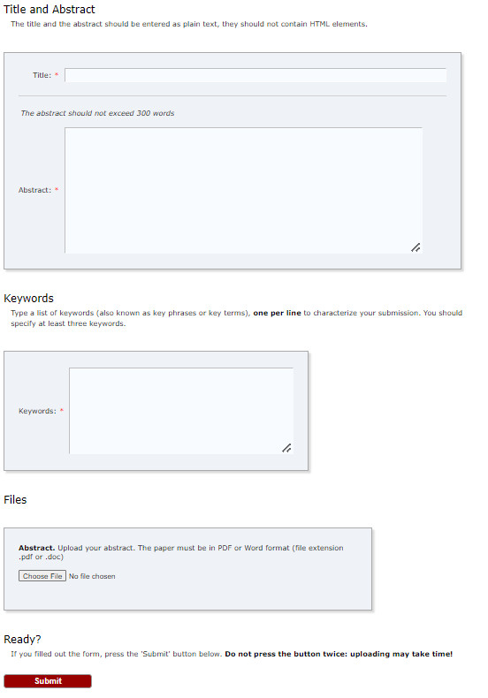
Figure 8. Abstract information
Click on the “Submit” link to submit your abstract (as shown in Figure 8).
Please do not submit the full paper at this stage.
After completing a submission, a new menu bar (“Submission #”) is created in the case of multiple submissions (as shown in Figure 09).
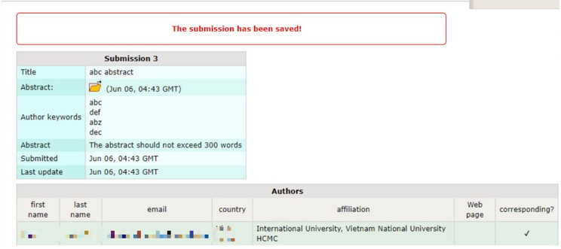
Figure 9. A page for changing submission
Use the links at the top-right corner for:
- Updating information about your submission: select “Update information” from the right-hand menu of the Submission screen to change any of your submission's title, abstract, and keywords.
- Updating author information for your submission: select “Update authors” to modify any information about the author(s) and click “save.” In the case of multiple authors, you can add (“Add new author”) or remove authors (Click on “X”); then update the order of the authors by selecting the “Reorder authors” button.
- Uploading files: the “Update file” link may be used to upload files. Please do not upload any full-text paper files at this stage.
- Withdrawing the submission: select “Withdraw” to withdraw the submission.
At the end of the submission procedure (a new submission or an update of an old one), you will receive a confirmation email from the EasyChair system. Once the review process is completed, you will receive an acceptance/rejection notification with reviews by email.
- Full-text paper submission
You can submit a full-text paper only by updating your submission as a Fulltext. Once you have completed the abstract submission, the menu bar "Submission #" or "My Submissions" is created for multiple submissions. You will access information about your submission by clicking on this tab, as shown in Figure 09. In particular, you may change the necessary information using the menu in the top-right corner. Most importantly, you have to submit a full-text paper by selecting “Update file” in “Full-text”. After clicking on “Update file”, you will be able to choose the file you want to upload with the link “Select file”.
Once the full-text paper review process is completed, you will receive an acceptance/rejection notification with reviews by email.
- Revised paper submission
We will notify you if there are any modifications to your article during this period. You will have to edit as required and resubmit by clicking "Update file", then "Submit".
- Final paper submission
If your full-text paper was accepted, we request that you submit your revised paper electronically. To upload your final paper, click on "Submission #" and select “Update file” from the right-hand menu of the Submission screen. After selecting the file that you wish to upload from your computer, submit your revised paper by choosing the “Submit” button.

