**EXPECTATIONS FOR INTERNSHIP STUDENTS ACADEMIC YEAR: 2024 – 2025**

*This document is to provide the internship companies of BME students with guideline to mentor them during the internship period.*

1. 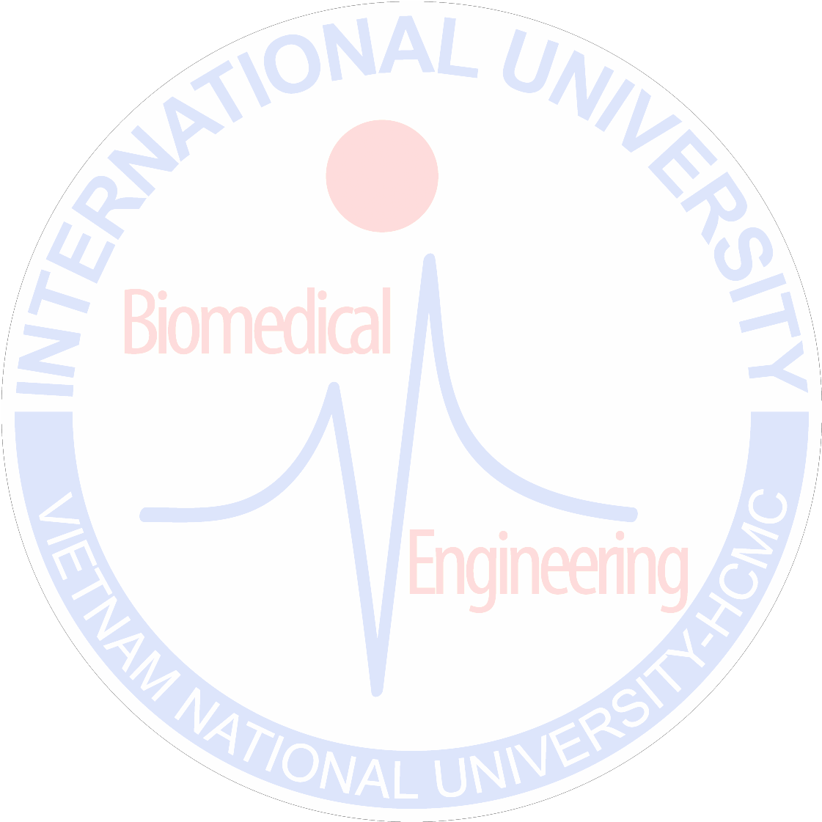Instruct the students to follow regulations of the company during the internship period?
2. Require the students to complete the required time for the internship period at the company.
3. Instruct the students and create opportunities so that they can make helpful contribution to the realistic activities of the company during the internship period. More specific examples are described in page 2. Please note that these are internship activities that our students conducted in previous year. Current internship activities do not need to limit to what described in this form.
4. Provide students with opportunities to collaborate with divisions in the company
5. Evaluate and give feedback for the students to that they create and maintain a good relationship and good communication with everyone in the company.
6. Create opportunity for the students to apply what they learnt at university to real situations at the company
7. Create opportunity for the students to acquire new skills and/or knowledge during the internship period
8. Advise the students to solve problems/ requirements set up by the advisor at the company



|  |  |  |
| --- | --- | --- |
| **No.** | **Type of companies/ institutions** | **Internship activities** |
| 1 | Tissue engineering and regenerative medicine companies and insititutes | Internship activities at TERM companies:   * Planning and implementing activities on projects related to scale-up, validation, and technology transfer * Overseeing and/or executing equipment/process qualification; writing and reviewing qualification/validation/technical reports.   Internship activities at TERM research institutes include:   * Participating in hands-on projects under the supervision of a researcher by reviewing project topics, developing and designing experiment protocols, conducting experiments, reporting data on a regular basis, and presenting new findings of papers relevant to project topics in group seminars. * Studying working principles and applications of special equipment (such as FTIR, SEM, etc.) as well as getting hands-on training on operating them. |
| 2 | Pharmaceutical companies and insititutes | * Planning and implementing activities on projects related to scale-up, validation, and technology transfer in Pharmaceutical Companies (Long) * Studying working principles and applications of special equipments to produce Pharmaceutical products (Long) * Quality assessment and Quality control of Biochemical, Medical herb and Pharmaceutical products (Long) |
| 3 | Clinical test companies/hospitals | * Planning and implementing activities on projects related to scale-up, validation, and technology transfer in In vitro diagnostics * Studying working principles and applications of Instruments espcially the Automatic Analyzer systems in In vitro Diagnostics * Quality assessment and Quality control * Participating in activities including Laboratory Operations, Test Procedures, Quality Control/Documentation, Instrument Fixing and Maintenance, Safety... |
| 4 | Medical instrument companies | * Following the regulations of the company during the internship period. * Reading to study or translate documents about the machines of the company. * Participating in the installation of machinery at hospitals and medical facilities. * Operating instructions of the machines for the doctors and technicians. * Carrying out maintenance, repair and operation of machines. * Collaborating with the colleagues to operate the production chain. * Designing the method validation for equipment and tests |



|  |  |  |
| --- | --- | --- |
|  |  | under the instruction of supervisor  - Researching on novel methods to improve the product quality of the company |
| 5 | Signal processing/data science/ AI | * Following the regulations of the company during the internship period. * Reading to study or translate documents about the machines of the company. * Practising the measurement and acquisition of biomedical signals/images. * Conducting the processing and analysis of biomedical signals/images. |